Ralph Mora

Assignment 6.3

11/15/2023

In this assignment, we take the same data sets from 6.1 and 6.2. This time we will use an SVM classifier to solve the classification problem. First, we will use a linear kernel, then a 3rd order Volterra expansion, and then finally an RBF (Radial Basis Function) kernel. Then we will compute the test error for each.

**The following plots are for when a = 0.2**

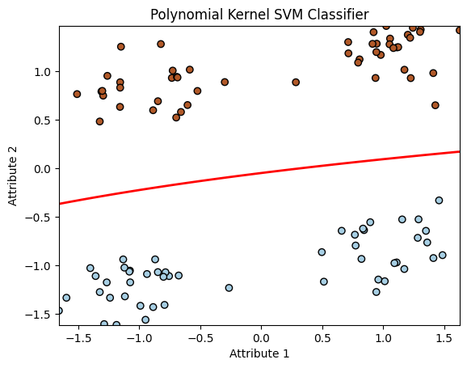

As we can see there is no problem classifying each group. That is because if 2 dimensions is enough to solve the problem. Then there is no reason to raise the number of dimensions.

**The following plots are for when a = 1.5**

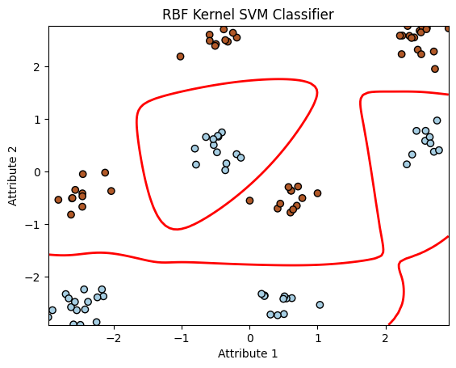

As we can see using 2 dimensions is not enough to solve this problem. So, we test out data with a 3rd Order Volterra polynomial which has a dimension of 10. Finally, we need to us the Radial Basis Function to correctly classify each group with 0 error.